RC tutorial 005 - Alignment with cant (superelevation). The Alignment Coordinate System.

===============================================================================

· Assumed RailCOMPLETE skills: Previous lessons.

· Assumed railway skills: You know about railway geometry, vertical profile, cant (superelevation), and right-handed coordinate systems.

· Time to spend: 20 minutes.

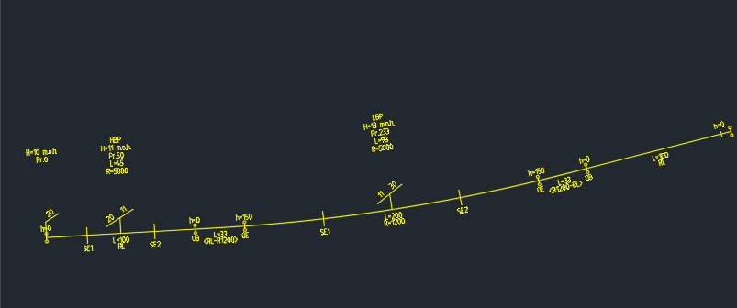

1. This tutorial makes use of the Norwegian State Railways' model (Bane NOR DNA).

2. The RailCOMPLETE definitions for the Bane NOR network assets measure most lengths in meters and use decimal degrees for presenting angular measures. Cant (superelevation) is measured in millimeters, according to the LandXML 1.2 definitions for metric projects.

NOTE: Some alignment design packages express cant in meters or other units. You may have to scale cant upon importing or exporting alignments with cant data.

3. Your CAD editor is assumed to operate in a Cartesian XYZ world coordinate system (WCS) set to meter [m] unit for each axis. To express your object's coordinates in another Cartesian X'Y'Z' user coordinate system (UCS), use AutoCAD command UCS to set the new origo and axis directions, then use PLAN or EXPLAN to rotate your view so the X' axis points straight right on your screen. To view objects from other angles you may rotate your CAD view. Hold down the "Shift" key while pressing the mouse scrollwheel down and moving your mouse. The RailCOMPLETE Property Manager always shows geoCoord XYZ as WCS coordinates.

4. With RailCOMPLETE we speak about the xyz "alignment coordinate system" (ACS). This is to be interpreted as yet another local Cartesian (orthogonal) axis system which 'slides' along a specific alignment in the direction of increasing mileage. Origo is located at a specific position 's', where s - named 'Position' - is measured in meters along the alignment from the start of the alignment's XY plane geometry up to the xyz origo. The local ACS y-axis is colinear with the local geometry tangent direction, which is always a vector in the WCS XY plane, and pointing in the direction of increasing position (increasing mileage). The local ACS z-axis is always colinear with the WCS Z-axis, i.e. pointing 'straight up in the air'. The local ACS x-axis is oriented orthogonally to the y- and z- axes, forming a right-handed orthogonal axis system.

Hint: Imagine that "y" is your right-hand index finger which is pointing along the alignment in the increasing mileage direction, and "z" is your right-hand middle finger pointing straight up. Then "x" is your right-hand thumb, pointing to the right side of the alignment.

5. 'Position' is a continuous and strictly increasing distance measure along the alignment's 2D centre line, whereas the 'Mileage' is a piecewise linear mapping from Position to "railway position name" of that position - called "mileage" (German: Kilometrierung, French: Point kilometrique ("peh-kah")). The mileage mapping function is often called "chaining". The discontinuities in mileage are often called "chain breaks". With Bane NOR, the mileage is always increasing in the direction leading away from Oslo Central Station, with a zero in its track 7 where "the rain stops and the culvert starts" (except in Trondheim, where the mileage is re-set to zero for lines going North). Some administrations use continuous chaining as far as possible, whereas others (e.g. Trafikverket in Sweden) use mileage posts with a chain break at every kilometer of line or so. In the latter situation, railway positions (mileage, chaining) is often expressed as "xxx+yyyy" where xxx=previous mile post's integer kilometer value, and yyyy=offset in meters from the previous mile post. yyyy values are typically found between 900 to 1100 meters. With Bane NOR, mileage is expressed in drawings as either "xxx,yyy" where xxx=kilometers and yyy=meters from the zero mileage position, or sometimes "xxx,yyyyyy" when millimeter precision is needed.

6. In the RailCOMPLETE Property Manager, Object Manager and Alignment Manager, basic mileage values are expressed in meters (not kilometers).

7. Superelevation with Bane NOR is measured as a vertical uplift of one top-of-rail in relation to the other, expressed in milllimeters [mm]. When superelevation is applied to an object, be it a top-of-rail line, a balise, an axle counter, a switch or any other track-bound object, then we rotate the object's lateral position (x,z) around the local ACS y-axis and then translate it upwards by half the superelevation. In this way, both rails will be slightly moved inwards, and the lowest rail's top-of-rail will remain at the alignment's elevation at that position (i.e. at relative elevation zero). Viewed from the positive Z-axis, adding cant to an alignment this way does not change the geometry. If you had instead rotated e.g. a track around the lowest rail's top-of-rail, then the other rail and the centre line would have moved sideways towards the lower rail, which would lead to an unwanted change in alignment geometry.

8. Play a little around with the various alignment annotation tools: RC-ShowGeometry, RC-ShowProfile, RC-ShowMileage, RC-ShowAlignmentName, RC-ShowTwoRails.

9. Copy your track annotations to drawing before you start changing too much. Activate the alignment annotation tools, select the alignment, right-click and select "RailCOMPLETE Annotations\Copy Annotations to Drawing".

NOTE: For some reason, AutoCAD hides such annotations from time to time. Using the AutoCAD command AUDIT+"Yes" will usually fix this problem, even if AutoCAD reports "Total errors found 0 fixed 0.".

10. Start the Alignment Manager and select the alignment "T01". Check the "Bind to Selection" box.

11. Activate the Alignment\Cant tab. You will see a datagrid displaying the cant details of your alignment.

12. LandXML and AutoCAD CIvil 3D talk about "clockwise cant rotation" and "counterclockwise cant rotation". The mental reference is a 2D profile cut-through of your railway or road system, a drawing showing the inclined tracks / pavements and their surrounding banks, seen in the direction of increasing mileage. If you think of a superimposed clock's arrows, then lowering the right bank corresponds to increasing time (CW rotation) and vice versa. This is how also RailCOMPLETE denotes cant rotations.

NOTE 1: There is no required definition of CW / CCW reference system in the LandXML 1.2 XSD, so you may have to flip CW/CCW upon import or export of LandXML files to get things right.

NOTE 2: If we consider an object rotated with its alignment's cant rotation, expressed in the local Alignment Coordinate System (ACS), then a positive rotation about the local y axis I(which points in the direction of increasing mileage) will raise the left side above the right side, as viewed in the direction of increasing mileage.

13. Check the "Enable Edit" box to allow for modifications in the datagrid.

14. To visualize cant in 3D, you will need to express your railway track using sleepers and rails. Start the RC-Export3D command from the ribbon or from the keyboard (not the right-click shortcut version), and navigate to the Alignment tab, Check the "3D" box and verify that "Separation" is set to 0.6 meters. Select one of the standard sleeper & rail object models from the standard 3D library, for instance the object model NO-BN-3D-KO-SVI-SVILLE-BETONG-JBV60-SKINNE-60E1.dwg. It contains one sleeper and two 60 cm pieces of rail, i.e. a not-so-detailed visualization. Press the "Export" button to start expressing your BIM alignment as 3D.

15. Each time you have made changes to cant you may visualize them in 3D by selecting the alignment, right-clicking and selecting "RailCOMPLETE Export 3D" (command RC-Export3DUsingCurrentConfig). Your current settings from the RC-Export3D will be used.

16. Experiment with various settings for cant position, can value and rotation. Select and delete your previous 3D exports if you don't want a messy model. For instance, check the effect of using exaggerated cant values and reversing cant rotation directions. The usual maximum cant for railway tracks is around 150 mm. Setting it to 1500 mm or above results in a vertical track (90 degrees roll about the ACS y-axis).

Please check our website www.railcomplete.com for updates.

Corrections and suggestions are welcome to' support@railcomplete.no.

Thank you for using RC Tutorials!